Exclusion Statistics

One Sample T-test - Percent Social Chosen Pre Exclusion compared to chance (50%), N=28

| **One Sample T-Test** | | | | | | | | | | | | | | | | | | | | | | | | | | | | | | | | | |
| --- | --- | --- | --- | --- | --- | --- | --- | --- | --- | --- | --- | --- | --- | --- | --- | --- | --- | --- | --- | --- | --- | --- | --- | --- | --- | --- | --- | --- | --- | --- | --- | --- | --- |
|  | | | | | | | | | | | | | | | | | | | | | | | | | | | | **95% Confidence Interval** | | | |  | |
|  | |  | | | | | **statistic** | | | | | | **df** | | | | **p** | | | | | **Mean difference** | | | | | | **Lower** | | **Upper** | | **Cohen's d** | |
| %Social Chosen Pre |  | Student's t | | | |  | 5.81 | | | | |  | 27.0 | | |  | < .001 | | | |  | 0.162 | | | | |  | 0.105 |  | 0.219 |  | 1.10 |  |
| Note. Hₐ population mean ≠ 0.5 | | | | | | | | | | | | | | | | | | | | | | | | | | | | | | | | | |
|  | | | | | | | | | | | | | | | | | | | | | | | | | | | | | | | | | |
| **Test of Normality (Shapiro-Wilk)** | | | | | | | | | | | | | | | | | | | | | | | | | |
|  | | | | | | | |  | | |  | | | | |  | | |  | | | |  | | |
|  | | | | | | | | | | | **W** | | | | | | | | **p** | | | | | | |
| %Social Chosen Pre | | | | | | | |  | | | 0.984 | | | | |  | | | 0.926 | | | |  | | |
| Note. A low p-value suggests a violation of the assumption of normality | | | | | | | | | | | | | | | | | | | | | | | | | |
|  | | | | | | | | | | | | | | | | | | | | | | | | | |
| **Descriptives** | | | | | | | | | | | | | | | | | | | | | | | | |
|  | |  |  |  |  | | | |  |  | | | |  |  | | |  | |  | | | |  |
|  | | | **N** | | **Mean** | | | | | **Median** | | | | | **SD** | | | | | **SE** | | | | |
| %Social Chosen Pre | |  | 28 |  | 0.662 | | | |  | 0.657 | | | |  | 0.148 | | |  | | 0.0279 | | | |  |
|  | | | | | | | | | | | | | | | | | | | | | | | | |

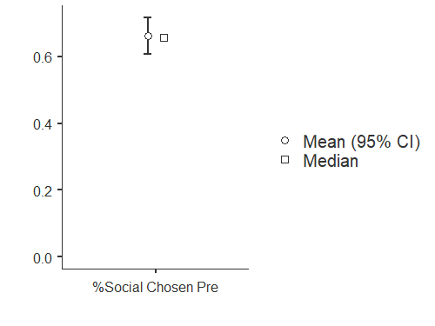

One Sample T-test- Percent Social Chosen Post Exclusion compared to Chance (50%)

| **One Sample T-Test** | | | | | | | | | | | | | | | | | | | | | | | | | | | | | | | | | | | | | | | | |
| --- | --- | --- | --- | --- | --- | --- | --- | --- | --- | --- | --- | --- | --- | --- | --- | --- | --- | --- | --- | --- | --- | --- | --- | --- | --- | --- | --- | --- | --- | --- | --- | --- | --- | --- | --- | --- | --- | --- | --- | --- |
|  | | | | | | | | | | | | | | | | | | | | | | | | | | | | | **95% Confidence Interval** | | | | | | | | | |  | |
|  | |  | | | | | | | **statistic** | | | | | **df** | | | | **p** | | | | | | | **Mean difference** | | | | **Lower** | | | | | | | | **Upper** | | **Cohen's d** | |
| %Social Chosen Post |  | Student's t | | | |  | | | 4.39 |  | | | | 27.0 | |  | | < .001 | | |  | | | | 0.146 | |  | | 0.0776 | | | | | | |  | 0.214 |  | 0.830 |  |
| Note. Hₐ population mean ≠ 0.5 | | | | | | | | | | | | | | | | | | | | | | | | | | | | | | | | | | | | | | | | |
|  | | | | | | | | | | | | | | | | | | | | | | | | | | | | | | | | | | | | | | | | |
| **Test of Normality (Shapiro-Wilk)** | | | | | | | | | | | | | | | | | | | | | | | | | | | | | | | | | | |
|  | | | | | | | | | | |  | | | |  | | | | | |  |  | | | | | | | | |  | | | |
|  | | | | | | | | | | | | | | | **W** | | | | | | | **p** | | | | | | | | | | | | |
| %Social Chosen Post | | | | | | | | | | |  | | | | 0.984 | | | | | |  | 0.933 | | | | | | | | |  | | | |
| Note. A low p-value suggests a violation of the assumption of normality | | | | | | | | | | | | | | | | | | | | | | | | | | | | | | | | | | |
|  | | | | | | | | | | | | | | | | | | | | | | | | | | | | | | | | | | |
| **Descriptives** | | | | | | | | | | | | | | | | | | | | | | | | | | | | | | | | |
|  | | |  |  |  | |  | | | |  |  | | | |  | | |  | | | |  | | |  | | | |  | | |
|  | | | | **N** | | | **Mean** | | | | | **Median** | | | | | | | **SD** | | | | | | | **SE** | | | | | | |
| %Social Chosen Post | | |  | 28 |  | | | 0.646 | | |  | | 0.663 | | | |  | | | 0.175 | | | |  | | | | 0.0332 | | | |  | |
|  | | | | | | | | | | | | | | | | | | | | | | | | | | | | | | | | |

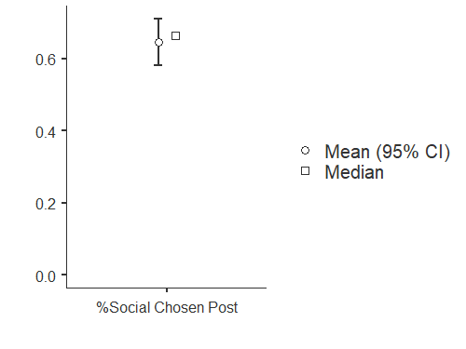

Correlation Between Scores on the AQ and Percent Social Chosen Pre Exclusion

| **Correlation Matrix** | | | | | | | |
| --- | --- | --- | --- | --- | --- | --- | --- |
|  |  |  |  |  |  |  |  |
|  | |  | | **AQ** | | **%Social Chosen Pre** | |
| AQ |  | Pearson's r |  | — |  | -0.417 | * |
|  |  | p-value |  | — |  | 0.027 |  |
|  |  | 95% CI Upper |  | — |  | -0.051 |  |
|  |  | 95% CI Lower |  | — |  | -0.683 |  |
| %Social Chosen Pre |  | Pearson's r |  |  |  | — |  |
|  |  | p-value |  |  |  | — |  |
|  |  | 95% CI Upper |  |  |  | — |  |
|  |  | 95% CI Lower |  |  |  | — |  |
| Note. * p < .05, ** p < .01, *** p < .001 | | | | | | | |
|  | | | | | | | |

**Plot**

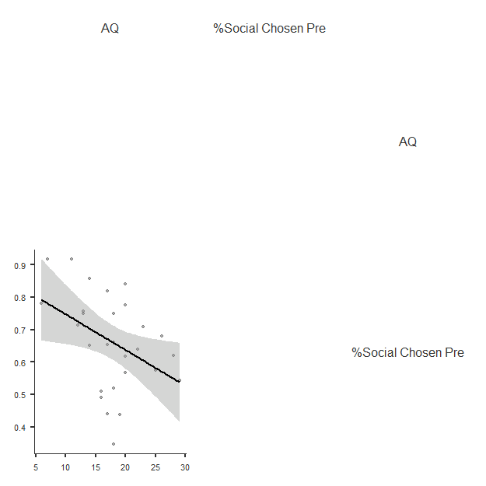

Correlation Between Scores on the AQ and Percent Social Chosen Post Exclusion

| **Correlation Matrix** | | | | | | | |
| --- | --- | --- | --- | --- | --- | --- | --- |
|  |  |  |  |  |  |  |  |
|  | |  | | **AQ** | | **%Social Chosen Post** | |
| AQ |  | Pearson's r |  | — |  | -0.363 |  |
|  |  | p-value |  | — |  | 0.058 |  |
|  |  | 95% CI Upper |  | — |  | 0.012 |  |
|  |  | 95% CI Lower |  | — |  | -0.648 |  |
| %Social Chosen Post |  | Pearson's r |  |  |  | — |  |
|  |  | p-value |  |  |  | — |  |
|  |  | 95% CI Upper |  |  |  | — |  |
|  |  | 95% CI Lower |  |  |  | — |  |
| Note. * p < .05, ** p < .01, *** p < .001 | | | | | | | |
|  | | | | | | | |

**Plot**

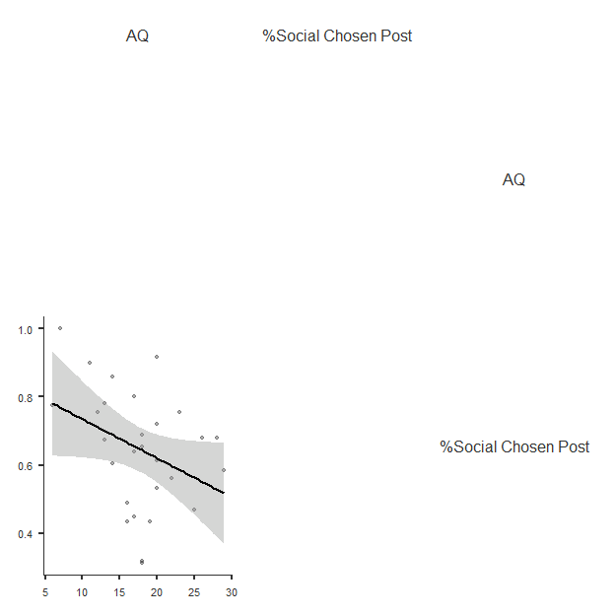

Correlation Between Scores on the MSPSS and Percent Social Chosen Pre Exclusion

| **Correlation Matrix** | | | | | | | |
| --- | --- | --- | --- | --- | --- | --- | --- |
|  |  |  |  |  |  |  |  |
|  | |  | | **MSPSS avg** | | **%Social Chosen Pre** | |
| MSPSS avg |  | Pearson's r |  | — |  | 0.259 |  |
|  |  | p-value |  | — |  | 0.183 |  |
|  |  | 95% CI Upper |  | — |  | 0.576 |  |
|  |  | 95% CI Lower |  | — |  | -0.126 |  |
| %Social Chosen Pre |  | Pearson's r |  |  |  | — |  |
|  |  | p-value |  |  |  | — |  |
|  |  | 95% CI Upper |  |  |  | — |  |
|  |  | 95% CI Lower |  |  |  | — |  |
| Note. * p < .05, ** p < .01, *** p < .001 | | | | | | | |
|  | | | | | | | |

**Plot**

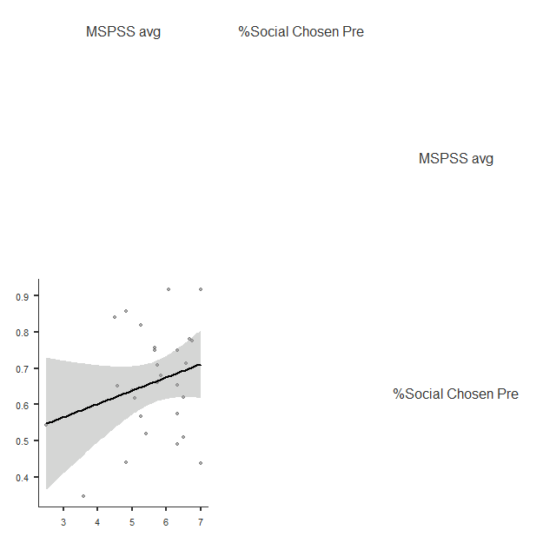

Correlation Between Scores on the MSPSS and Percent Social Chosen Post Exclusion

| **Correlation Matrix** | | | | | | | |
| --- | --- | --- | --- | --- | --- | --- | --- |
|  |  |  |  |  |  |  |  |
|  | |  | | **MSPSS avg** | | **%Social Chosen Post** | |
| MSPSS avg |  | Pearson's r |  | — |  | 0.210 |  |
|  |  | p-value |  | — |  | 0.284 |  |
|  |  | 95% CI Upper |  | — |  | 0.541 |  |
|  |  | 95% CI Lower |  | — |  | -0.177 |  |
| %Social Chosen Post |  | Pearson's r |  |  |  | — |  |
|  |  | p-value |  |  |  | — |  |
|  |  | 95% CI Upper |  |  |  | — |  |
|  |  | 95% CI Lower |  |  |  | — |  |
| Note. * p < .05, ** p < .01, *** p < .001  **Plot**  http://127.0.0.1:50733/05fdac42-353e-4ea6-84c1-dd65db6f2d49/13/res/13%20corrMatrix/resources/41d0a6dfede8a25d.png | | | | | | | |
|  | | | | | | | |

Paired Samples t test for money spent on social experiences pre and post exclusion

| **Paired Samples T-Test** | | | | | | | | | | | | | | | | | | | | | |
| --- | --- | --- | --- | --- | --- | --- | --- | --- | --- | --- | --- | --- | --- | --- | --- | --- | --- | --- | --- | --- | --- |
|  | | | | | | | | | | | | | | | | **95% Confidence Interval** | | | |  | |
|  | |  | |  | | **statistic** | | **df** | | **p** | | **Mean difference** | | **SE difference** | | **Lower** | | **Upper** | | **Cohen's d** | |
| $Pre Social (SvsNS) |  | $Post Social (SvsNS) |  | Student's t |  | 1.58 |  | 27.0 |  | 0.126 |  | 0.0418 |  | 0.0264 |  | -0.0125 |  | 0.0961 |  | 0.299 |  |
|  | | | | | | | | | | | | | | | | | | | | | |

| **Descriptives** | | | | | | | | | | | |
| --- | --- | --- | --- | --- | --- | --- | --- | --- | --- | --- | --- |
|  |  |  |  |  |  |  |  |  |  |  |  |
|  | | **N** | | **Mean** | | **Median** | | **SD** | | **SE** | |
| $Pre Social (SvsNS) |  | 28 |  | 0.857 |  | 0.910 |  | 0.283 |  | 0.0536 |  |
| $Post Social (SvsNS) |  | 28 |  | 0.815 |  | 0.860 |  | 0.367 |  | 0.0694 |  |
|  | | | | | | | | | | | |

## Plots

### $Pre Social (SvsNS) - $Post Social (SvsNS)

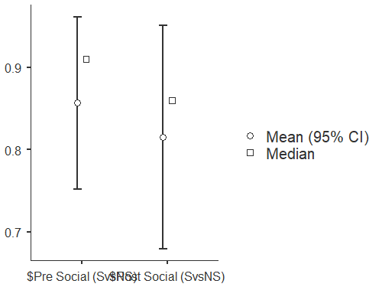

Paired Samples T test for total money spent pre and post exclusion

| **Paired Samples T-Test** | | | | | | | | | | | | | | | | | | | | | |
| --- | --- | --- | --- | --- | --- | --- | --- | --- | --- | --- | --- | --- | --- | --- | --- | --- | --- | --- | --- | --- | --- |
|  | | | | | | | | | | | | | | | | **95% Confidence Interval** | | | |  | |
|  | |  | |  | | **statistic** | | **df** | | **p** | | **Mean difference** | | **SE difference** | | **Lower** | | **Upper** | | **Cohen's d** | |
| $Pre Total |  | $Post Total |  | Student's t |  | 2.05 |  | 27.0 |  | 0.050 |  | 0.0918 |  | 0.0447 |  | -2.38e−5 |  | 0.184 |  | 0.388 |  |
|  | | | | | | | | | | | | | | | | | | | | | |

| **Descriptives** | | | | | | | | | | | |
| --- | --- | --- | --- | --- | --- | --- | --- | --- | --- | --- | --- |
|  |  |  |  |  |  |  |  |  |  |  |  |
|  | | **N** | | **Mean** | | **Median** | | **SD** | | **SE** | |
| $Pre Total |  | 28 |  | 1.85 |  | 1.99 |  | 0.331 |  | 0.0625 |  |
| $Post Total |  | 28 |  | 1.76 |  | 1.96 |  | 0.476 |  | 0.0900 |  |
|  | | | | | | | | | | | |

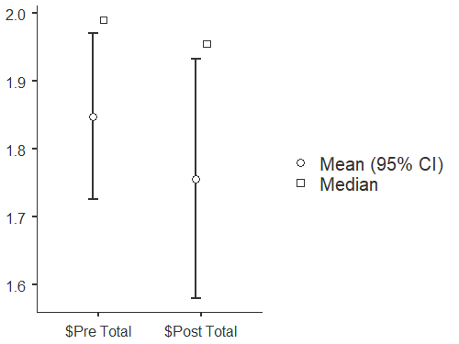

Paired t test for money spent on social vs non social pre exclusion

| **Paired Samples T-Test** | | | | | | | | | | | | | | | | | | | | | |
| --- | --- | --- | --- | --- | --- | --- | --- | --- | --- | --- | --- | --- | --- | --- | --- | --- | --- | --- | --- | --- | --- |
|  | | | | | | | | | | | | | | | | **95% Confidence Interval** | | | |  | |
|  | |  | |  | | **statistic** | | **df** | | **p** | | **Mean difference** | | **SE difference** | | **Lower** | | **Upper** | | **Cohen's d** | |
| $Pre Social (SvsNS) |  | $Pre Nonsocial |  | Student's t |  | 5.94 |  | 27.0 |  | < .001 |  | 0.474 |  | 0.0798 |  | 0.311 |  | 0.638 |  | 1.12 |  |
|  | | | | | | | | | | | | | | | | | | | | | |

| **Descriptives** | | | | | | | | | | | |
| --- | --- | --- | --- | --- | --- | --- | --- | --- | --- | --- | --- |
|  |  |  |  |  |  |  |  |  |  |  |  |
|  | | **N** | | **Mean** | | **Median** | | **SD** | | **SE** | |
| $Pre Social (SvsNS) |  | 28 |  | 0.857 |  | 0.910 |  | 0.283 |  | 0.0536 |  |
| $Pre Nonsocial |  | 28 |  | 0.383 |  | 0.375 |  | 0.178 |  | 0.0336 |  |
|  | | | | | | | | | | | |

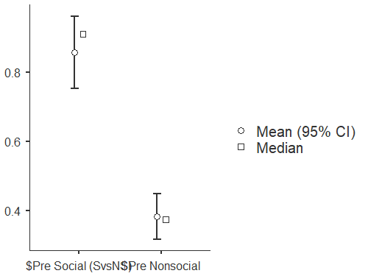

Paired t test for money spent post exclusion social vs non social

| **Paired Samples T-Test** | | | | | | | | | | | | | | | | | | | | | |
| --- | --- | --- | --- | --- | --- | --- | --- | --- | --- | --- | --- | --- | --- | --- | --- | --- | --- | --- | --- | --- | --- |
|  | | | | | | | | | | | | | | | | **95% Confidence Interval** | | | |  | |
|  | |  | |  | | **statistic** | | **df** | | **p** | | **Mean difference** | | **SE difference** | | **Lower** | | **Upper** | | **Cohen's d** | |
| $Post Social (SvsNS) |  | $Post Nonsocial |  | Student's t |  | 4.53 |  | 27.0 |  | < .001 |  | 0.440 |  | 0.0971 |  | 0.241 |  | 0.640 |  | 0.857 |  |
|  | | | | | | | | | | | | | | | | | | | | | |

| **Descriptives** | | | | | | | | | | | |
| --- | --- | --- | --- | --- | --- | --- | --- | --- | --- | --- | --- |
|  |  |  |  |  |  |  |  |  |  |  |  |
|  | | **N** | | **Mean** | | **Median** | | **SD** | | **SE** | |
| $Post Social (SvsNS) |  | 28 |  | 0.815 |  | 0.860 |  | 0.367 |  | 0.0694 |  |
| $Post Nonsocial |  | 28 |  | 0.375 |  | 0.395 |  | 0.203 |  | 0.0384 |  |
|  | | | | | | | | | | | |

## Plots

### $Post Social (SvsNS) - $Post Nonsocial

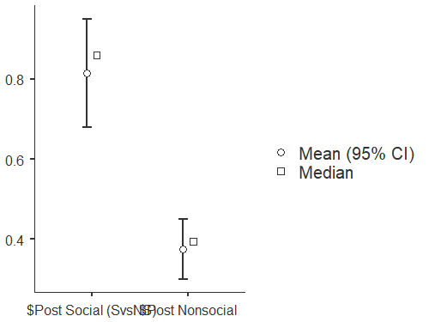

* This surprised me because I would have thought that the gap would have closed more, as we hypothesized that social experiences would lose their value following the experienced exclusion – I did another analysis between the differences of money spent on social vs nonsocial pre exclusion, and the differemces of money spent social vs non social post exclusion, and it was found that the differences were less great post exclusion, but not significant.

P

hh